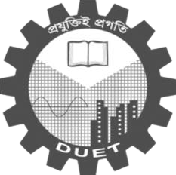

**Dhaka University of Engineering & Technology, Gazipur**

Department of Computer Science and Engineering

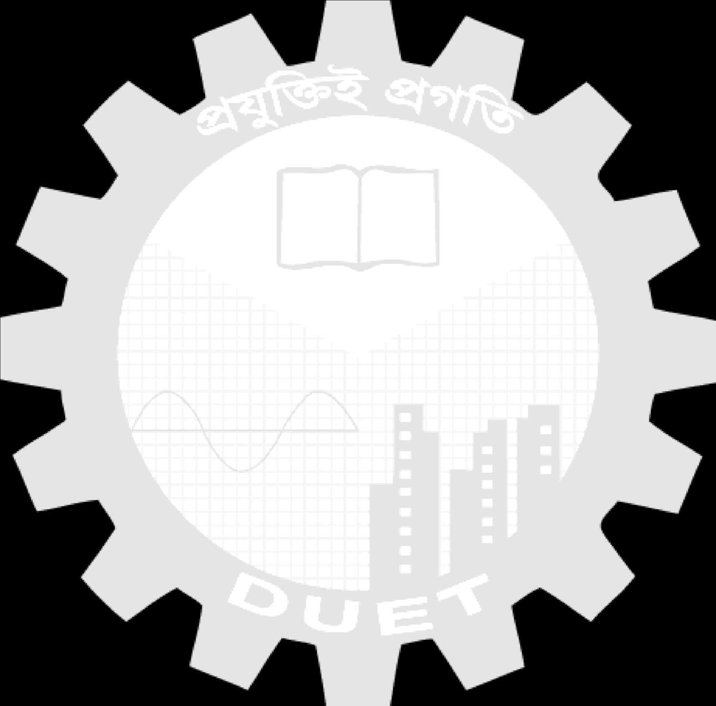

Course Code: CSE 2110

Course Title: Advance programming sessional

|  |  |  |  |
| --- | --- | --- | --- |
| Date of Experiment : 14 / 08 / 23 |  |  |  |
| Date of Submission : 28 / 08 / 23 |  |  |  |

# Report No - 03

**Name of the Report – Basic python Programming practice with Dictionary and**

**the Project Model.**

**Submitted To**

**Dr. Umme Fawzia Rahim**

Assistant Professor

Department of CSE

DUET, Gazipur

**Md. Rajibul Islam**

Lecturer

Department of CSE

DUET, Gazipur



**Submitted By**

Name :

Student ID :

Year/Semester: 2ndYear/ 1st Semester Section: A

Signature of Teacher